Code Inspection Document

Login Page

The layout of the login page was designed to follow a pleasant looking blue coloured theme, with the title of the system stated clearly at the top of the page, as well as a simple, easy to use login menu.

In order to not confuse the user, the login form is very straight forward and does not require much context to use:

All input fields in the login form are required and will show an alert when attempting to login without filling them all in:

When hovering over the ‘Login’ button, the colour will change:

When all of the details entered are correct and the ‘Login’ button is clicked, the page will automatically redirect the user to their respective page based on their user type (if they are a student, they will be redirected to the student page, if they are a supervisor, they will be redirected to the supervisor page and so on):

Module Coordinator – View Students Page

Following on from the login page, the layout of this page has the same blue theme with the title and subtitle of the system displayed clearly at the top.

This page contains a navigation bar, with links to the ‘View Supervisors’ Page, ‘View Projects’ Page and a button to log out:

There is also a feature that allows the user to add or update a student’s information. By default, this form allows the user to add a new student, but by clicking the ‘Update’ button in the database table, the form changes to ‘Update Student Information’. The form fetches information such as ‘Supervisor ID’ and ‘Supervisor Name’ directly from the database:

There is also a search bar function to search through the records in the database:

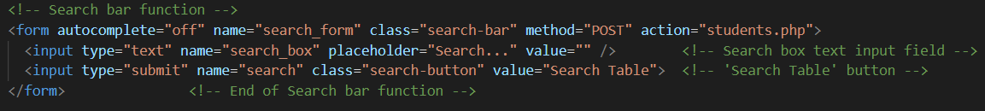

Finally, the database table shows a list of all of the students, along with their details and allocated project and supervisor. This information is retrieved from the database and is automatically updated when any changes are made or if a student is added or deleted:

To maintain standardisation and avoid any confusion, the same layout is established in the Module Coordinator ‘View Supervisors’ and ‘View Projects’ pages.

Student Home Page

The Student’s Home Page follows the same blue themed layout and has navigation bar links to the ‘Home’ page, ‘Choose Project’ page and to logout:

Students can use this page to view their own specific details and allocated project by retrieving their records based on their userID. The code does not allow a student to view any other student’s details or to edit or delete them in any way:

Student’s Choose Project Page

This page can be accessed directly from the student Home page and contains navigation bars to the other student pages:

On this page, students can view all of the available projects in a database table that automatically updates when projects are added, updated or deleted by supervisors or the module coordinator:

To avoid making the table look messy and show too much unnecessary information at one time, the description of projects is stored in a collapsible box, that when clicked, opens to reveal the information:

The page also has a search bar function to easily find database records:

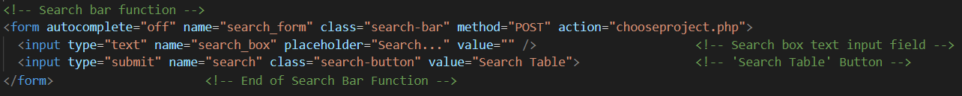

The student can also update their chosen project using the form below:

After updating their chosen project, a message is displayed to the screen:

Supervisor Home Page

The supervisor home page contains navigation bar links to the supervisor pages – the ‘Home’ page, the ‘View Allocated Students’ page and to logout:

Based on the supervisor’s userID, the supervisor can only view their own details and will not be able to view anyone else’s information or edit or delete them:

They are also able to view their own projects:

Supervisors can also add, update or delete their own projects by filling out the form. By default the form allows the user to first add a project, but if they click the ‘Update’ button in the database table, the form will automatically change to ‘Update Project Information’:

When a project is added, updated or deleted, a confirmation message will appear on the screen:

Supervisor View Allocated Students Page

This page contains navigation bar links to the other supervisor pages – the ‘Home’ page, the ‘View Allocated Students’ page and to logout:

On this page, supervisors can view their own allocated students who have chosen one of their projects. The database table uses the supervisor’s userID to retrieve only their specific allocated students and displays their information and allocated project:

